Saqi: Offline, Decentralized Water Intelligence for the Farms the Cloud Forgets
Fatma Ezzahra Jlali
Pioneer High School, Manouba, Tunisia
Moonshot 2026
Abstract. Modern precision agriculture assumes cloud connectivity, grid power, and capital, the very resources missing on the smallholder farms most exposed to climate change. I argue that the opposite design is correct: agricultural intelligence should run entirely at the edge, with no internet and no central server. I present Saqi, a scheme in which each zone of a grove carries a cheap device that communicates only with its neighbours and, through neighbour-to-neighbour gossip (average consensus), agrees on how to allocate a scarce shared water budget so that every zone stays alive. In simulation, Saqi matches a full-information central optimum when the network is intact; it remains effective, unlike the central system, when the network is partitioned; and it degrades more gracefully as the farm grows. I then extend Saqi from allocation to actuation, modelling how each node decides when to stop watering under sensor lag, and show that the same decentralized approach controls the valves without over-watering. For shared, scarce resources in infrastructure-poor regions, decentralization is not a compromise but the more resilient design.
Index Terms. decentralized systems, edge computing, wireless mesh networks, average consensus, resource allocation, feedback control, precision agriculture, climate resilience.
1. The bet
Here is a claim that most people building agricultural technology would reject: the most useful thing we can do for the world's most vulnerable farms is to take the intelligence out of the cloud entirely. Every “smart farming” product I have read about begins the same way, by asking the farmer to connect to Wi-Fi, open an app, and sync to a server. That single assumption quietly decides who the technology is for. It is for farms with electricity, internet, money, and data. The farms that climate change is hitting hardest have none of these, and so the tools meant to fight drought pass over the people drought reaches first.
Saqi is the opposite design. Instead of one central computer that sees everything, every patch of a grove carries a cheap, solar-powered device that communicates only with its nearest neighbours, with no internet, no server, and no subscription. Together these devices decide where scarce water should go so that every part of the farm survives. I could not build the hardware in the time available, so I built a simulation and used it to test the idea honestly. The central result was not the one I expected. When the network is healthy, Saqi makes water decisions as good as a perfect, all-seeing central system. When the network breaks, which is exactly when a drought-stricken farm can least afford it, the central system collapses and Saqi keeps the grove alive.
2. The problem: the farms the cloud forgets
I grew up around olive trees. My family farms them in Sidi Bou Zid, in southern Tunisia, where a dry summer is a fact of the calendar. The mismatch with precision agriculture is, as a result, stark: these systems assume fibre internet and grid power, yet they target a problem that is worst precisely where those things do not exist.
This is not a small niche. There are more than 500 million smallholder farms in the world. Most are under two hectares, and together they produce roughly a third of the food we eat [3]. They are concentrated in the regions with the weakest infrastructure and the highest exposure to a warming climate. Cloud-first design does not merely underserve them. It structurally excludes them, because its first requirement is the one thing they cannot assume.
Beneath the connectivity gap lies a deeper one. Industrial agricultural AI is built to maximise yield when inputs are abundant. On a smallholder farm in a dry year, that is the wrong objective. The question is not how to grow the most; it is who receives the last litre of water so that nothing dies. Olives make the point well, because they survive on very little. The honest goal is not to fatten a few trees but to keep every part of the grove just above the line. That shift, from maximising a total to protecting the worst-off, is the core of what Saqi does.
3. Why current systems fail
A cloud system has a single point of failure, and it places that point exactly where infrastructure is weakest. Every node must report to one gateway and wait for its instructions. The moment the network or the power drops, which is the moment a drought is at its worst, the central controller goes blind and silent, and the zones it can no longer reach receive nothing. Adding satellites and connectivity does not solve this; it only makes the farmer depend on more infrastructure she does not own or control.
This failure is not a rare edge case. As I show below, an unreliable radio network does not degrade smoothly. Below a tipping point it largely holds together; above it, it shatters into disconnected islands, and a central controller loses whole regions of the farm at once. The very thing the cloud requires, a path from every node back to one place, is the first thing to break.
4. The idea: Saqi
Each zone of the grove carries a cheap microcontroller, the kind that costs a few dollars, runs off a small solar cell, and reads a soil-moisture probe. A short-range radio lets it talk only to the handful of zones around it. That web of local links forms a mesh: there is no centre, only neighbours.
The daily goal is the one the olives suggest: keep every zone above a thin survival line, rescuing the most desperate first, never sacrificing the weak to spoil the strong. The difficulty is achieving this when no node ever sees the whole farm. Saqi's answer is a decentralized “water-line.” Each connected piece of the mesh agrees on a single moisture cutoff; zones below it are watered to safety, and zones above it can wait. To find that cutoff without a central tally, the nodes gossip: each one repeatedly exchanges its water demand with its neighbours and averages, a process known as average consensus, tuned with Metropolis weights so that it settles quickly on the true field-wide picture [2]. Every node runs the same small computation and arrives at the same line. There is no server and no global view. If the mesh splits in two, each half simply solves its own smaller version of the problem, which is why breaking the network does not break Saqi.
5. How I tested it
I modelled a grove as a grid of zones. Each day the soil dries, faster on hot days; rain is rare; and a single shared water tank is deliberately too small to satisfy everyone, holding only about 60% of what the grove loses. A zone is lost only after roughly a week bone-dry, which reflects how much olives endure. Against this model I compared three ways of sharing the water. The naive timer splits it equally and ignores who is thirsty. The cloud controller has a god's-eye view and rescues the driest zones first until the tank is empty; it is the best any method can do on the budget, and serves as my upper bound. Saqi is the decentralized water-line. Every figure below is averaged over many randomised seasons, so it reflects the pattern rather than luck.
6. What I found
Decentralized is as good as central when the network is connected. Over 40 seasons, Saqi kept about 29 of 36 zones alive, statistically tied with the all-seeing cloud at 30, while the naive timer kept only 21 (Fig. 1). The first claim holds: the cloud is not necessary for near-optimal water decisions.
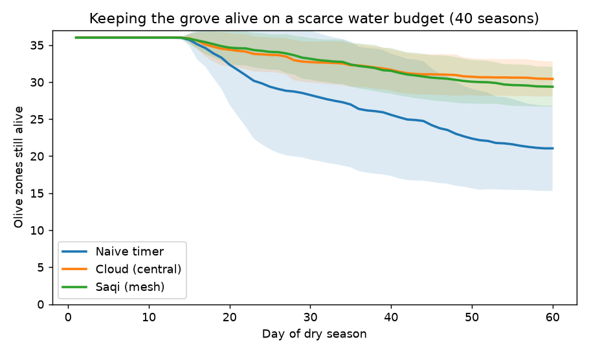
Fig. 1. With a healthy network, Saqi tracks the central optimum; the naive timer bleeds out. Mean of 40 seasons; shaded bands show spread.
When the network breaks, the cloud is the fragile choice. As I cut the radio links, the cloud held until about half were gone, then fell off a cliff; past that point it dropped below even the dumb timer, because it abandons every zone it can no longer reach (Fig. 2). Saqi degraded gently and stayed on top throughout. The sharp bend sits at roughly 50% of links, which is not a coincidence: one-half is the exact point at which a square lattice of this kind comes apart [4]. The whole argument lives in this one figure. The cloud is smart but brittle, the timer is robust but dumb, and Saqi is the only strategy that is both.
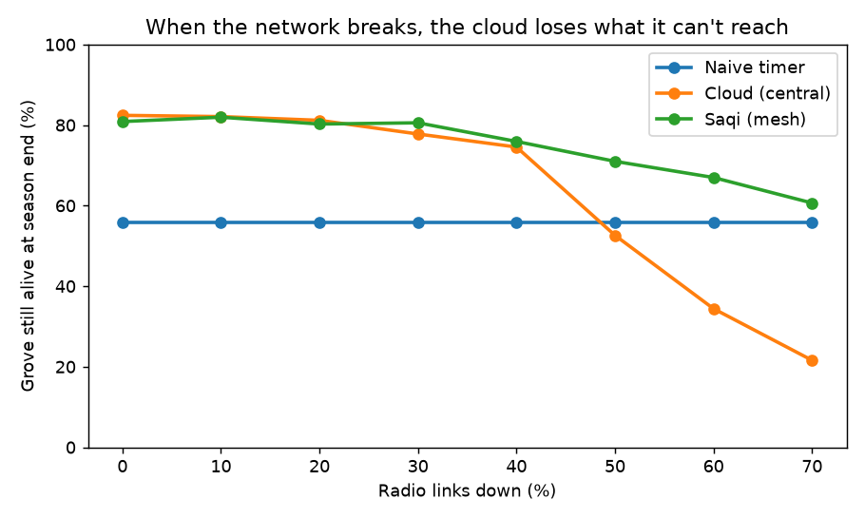
Fig. 2. As radio links fail, the central cloud collapses and even falls below the naive timer; Saqi degrades gracefully. Survival at season end vs. fraction of links down.
Centralizing gets worse at scale. Holding the network in a badly degraded state, I grew the grove. The larger the farm, the more an unreliable network fragments into isolated islands, so the cloud worsened as the grove grew, from 51% of zones alive at 16 zones to 34% at 100, while Saqi held and even improved, from 68% to 75% (Fig. 3). Centralization scales badly precisely where scale and stress meet, in large and poorly connected regions, which are the places that need it most.
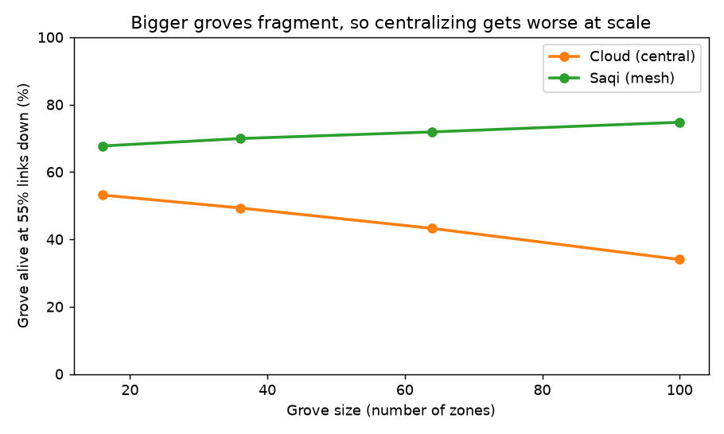
Fig. 3. In a degraded network (55% of links down), the cloud worsens as the grove grows while Saqi holds. Survival vs. number of zones.
7. From deciding to doing: the watering loop
The simulation so far answers who should receive water. Moving the idea toward real nodes surfaced a second question the allocation quietly skipped: once a valve opens, when should it close? Watering is not an instant transfer. Water enters at the emitter and takes time to spread to the root zone, so a moisture probe lags the water that has actually been applied. A node that waits until its sensor reads the target and only then shuts the valve will overshoot, because the water already in transit keeps arriving after the valve is closed. On a real grove that surplus drains below the roots and is lost, which is the very waste Saqi exists to prevent.
The fix is for each node to stop on committed water, the moisture already in the root zone plus the water still travelling toward it, rather than on the raw sensor reading. In a single-zone simulation the naive rule fills past field capacity and drains away about a tenth of the target depth, while the committed-water rule settles exactly on target and wastes nothing (Fig. 4). This is what it means, concretely, for a node to be smart: it has to estimate the settled state of its whole root zone, not trust one lagging point.
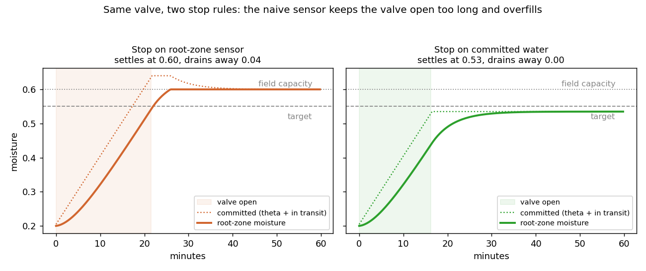
Fig. 4. One valve, two stop rules. Stopping when the root-zone sensor reads target lets water in transit overfill the zone past field capacity, and the excess drains away; stopping on committed water settles on target with no waste.
The same decentralized logic then coordinates the valves. A shared pump can feed only a few zones at once, so each node runs a small state machine: a satisfied zone closes its valve and signals that it is done, which frees the pump for the next thirsty neighbour. Across a nine-zone cluster the committed-water rule wasted no water to drainage while the naive rule lost about a fifth of what it delivered, keeping the same zones in band (Fig. 5). Coordination extends cleanly from deciding to doing.
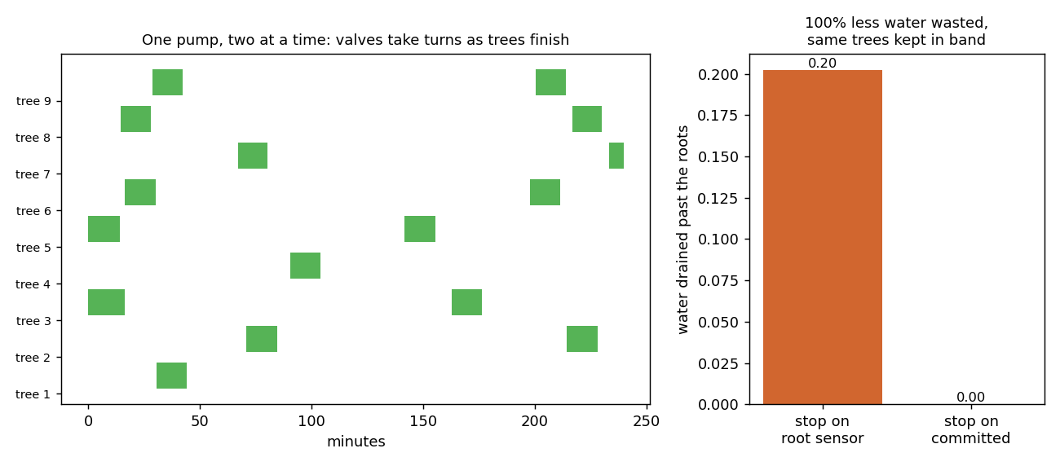
Fig. 5. One pump feeds two zones at a time; satisfied zones hand the pump to the next thirsty one. The committed-water stop rule wastes far less water to drainage than the naive sensor rule.
This control layer is still simulated, with a deliberately simple model of how water moves through soil. Its constants, how fast applied water reaches the roots, where field capacity sits, and how quickly each zone dries, have to be measured on a specific grove. Calibrating them is the first job of the physical nodes, and the loop above is what those nodes would run.
8. What I am not claiming
This is a simulation with an idealised model of soil and weather, and it tests coordination more than plumbing. The control layer in Section 7 is a first step toward the physical watering, but it too is simplified and awaits calibration on a real grove. I model the failure of decision-making and communication, not the full movement of water through soil. A real system would need cheap, field-tested hardware, soil calibration for a specific grove, and a season of trials. The gossip also assumes that each piece of the mesh has a rough sense of its own size, which neighbours can themselves estimate. None of these caveats touches the core finding, because that finding is structural: decentralized coordination survives conditions that break centralized control, and it does so by design rather than by luck.
9. Why this should exist
The components are available today. A zone needs a microcontroller, a moisture probe, a small solar cell, and a short-range radio, on the order of twenty dollars, with no internet bill and no data centre. The algorithm is light enough to run on a chip that costs less than a coffee. My next step is to move it off the screen and onto a few real nodes in my family's grove.
The larger idea is not about olives. For a decade we have tried to fight exclusion by extending the cloud outward, with more towers, more satellites, and more connectivity pushed toward the places that lack it. Saqi argues for the reverse: build intelligence that never needed the cloud in the first place. A shared, scarce resource managed by cheap local devices that only ever talk to their neighbours is not a downgrade for poor regions. For water, for small energy grids, for any commons in a place that infrastructure forgot, it is the more resilient design. If precision agriculture can run with no internet, no grid, and a few dollars per zone, it stops being a privilege of industrial farms and becomes available to the half-billion farms that already feed much of the world and stand first in line as the climate turns against them.
My country exports its olives in bulk and lets others attach the brand, the value, and the intelligence somewhere else. I do not want to repeat that pattern. The intelligence, and the resilience, should live where the people are. Saqi is one small proof that they can.
References
[1] P. Thiel, Zero to One: Notes on Startups, or How to Build the Future. Crown Business, 2014.
[2] L. Xiao and S. Boyd, “Fast linear iterations for distributed averaging,” Systems & Control Letters, vol. 53, no. 1, pp. 65–78, 2004.
[3] Food and Agriculture Organization of the United Nations, The State of Food and Agriculture: smallholder and family farms. FAO, Rome.
[4] H. Kesten, “The critical probability of bond percolation on the square lattice equals 1/2,” Communications in Mathematical Physics, vol. 74, pp. 41–59, 1980.

